ASSESSING CONFLICT

It is as inevitable as it is essential to a healthy relationship that conflict is present. It is not conflict that creates problems for churches and people, it is the capacity and competency of a church to deal with it in healthy ways that determines the extent of the problem. Most people and churches are not trained, experienced or skilled in dealing with conflict in healthy and faithful ways. So, the beginning point is to understand the extent or intensity of the conflict and types of conflict that contribute to the current moment.

Conflicts (multi-faceted, multi-leveled opportunities for intense dialogue) are never as simple as one source or origin of the conflict that has risen to only one level of intensity. In considering where a church finds itself in the potential mix, it can be helpful to chart the elements that contribute to the conflict. This process is encouraged in order to determine the best starting point to develop resiliency and identify the best resources to help the church be healthier, more faithful and more effective.

TYPES OF CHURCH CONFLICTS
Based on the YouTube video Working through Conflicts in the Church

- Relationship Conflicts: relationships are disrupted/broken by hurt, neglect, wounds from individual actions/patterns. Trust and hurt are core issues.
E.g. - people engage fight or flight because they feel personally attacked, betrayed or bullied by a person or group within the church.

- Data Conflicts: information is not fully known or shared, people act on the information they have or feel they lack. Perspective is a core issue.
E.g. – All of the information about the church’s current financial status and potential are not shared before a decision is made around expense cuts.

- Interest Conflicts: people push to get what they want, remain in their comfort zone or to avoid what they fear. Needs, wants and control are core issues.
E.g. – People disagree over the starting time for summer worship services or the color of the new Sanctuary carpet, or the choice of hymns.

- Structural Conflicts: changes in the stresses on the system happen by forces outside of individuals or the collective. Stress, anxiety and fear are core issues.
E. g. – The economics and demographics of the neighborhood around the church have changed and are impacting the ministry.

- Value Conflicts: perceived or actual differing value systems or incompatible belief systems. Fundamental philosophy, ideology and theology are core issues.
E.g. – Members fundamentally disagree on philosophy of local versus global mission, ONA or balancing the budget.

LEVELS OF CONFLICT
(based on a model by Speed Leas in Leadership magazine, 1989)

- “We have problems to solve, but we can do it! We have the skills and resilience”
- “We are not communicating well. There seems to be a low level of trust… but we are talking! We believe we have the skills or could learn the skills to work this out.”
- The focus has changed to “winners/losers!” Some people are leaving or withdrawing from the church. Or they are withholding their participation and contributions until they get what they want. There is not enough open communication through appropriate channels to understand or resolve the problem. At this level it is wise to seek outside help.
- The goal is “divorce” and getting people to quit. People are ostracizing, excluding and removing others from the church (including staff)
- The goal is not only wanting others to leave, but seeking revenge! Beyond the intention to win, there is also a desire to hurt others.

ASSESSMENT GRID
As you reflect on the current levels of conflict and communication in your church it is likely that you will check off multiple boxes. It is also likely that different people in the church will assess the church at different places. This creates a great opportunity for conversation and reflection.

LEVEL | RELATIONSHIP | DATA | INTEREST | STRUCTURAL | VALUE
1
2
3
4
5

Five goals govern most human behavior:
Alfred Adler, Rudolph Dreikers
Belonging
Power
Protection
Withdrawal
Challenge (added as part of the adolescent developmental stage that carries into adulthood)

Four Goals of Misbehavior
http://www.lifematters.com/step.asp
CONTACT: Undue Attention - All children desire and need attention. But a child who needs attention all the time will resort to behavior to keep others busy with him or get special treatment. Parents will feel annoyed, irritated, worried and/or guilty. The parent responds by scolding or warnings and the child is temporarily satisfied but not for long.
CONTROL: Power - For some children their mistaken goal is to be in charge and be the "boss". By their misbehavior they are saying "I am in control" or "You can't make me". Parents feel provoked, challenged, angry, threatened and/or defeated and will meet the child in a power struggle. If the parent gives in the child "wins" and stops the behavior until the next power struggle arises.
PROTECTION: Revenge - These children often feel they have been hurt or that they can never win in a power struggle. They feel the only way to belong is to get even. Parents feel hurt, disappointed, disbelieving, disgusted and rejected by this form of misbehavior.
WITHDRAWAL: Assumed Inadequacy - Often a child will just give up displaying helplessness. They want to be left alone so they have no expectations to live up to. Parents feel like giving up, doing for, over helping and helpless to do anything. For many children this form of misbehavior is displayed only in certain areas like homework or activities.
These four goals of misbehavior give parents the clues they need to redirect their children and help them find positive ways to achieve their need to belong. Understanding that children are not consciously plotting their misbehavior but it is based on a child's mistaken goal, goes a long way in promoting a respectful parenting style.

From Jonathan Haight’s: The Righteous Mind: Why Good People are Divided by Politics and Religion

5 Foundations of a Moral/Values Matrix
Pg 146 adapted

 | Care/  Harm | Fairness/  Cheating | Loyalty/  Betrayal | Authority/  subversion | Sanctity/  degregation
Evolutionary Adaptive  Challenge | Protect and care for children | Reap Benefits or two-way partnerships | Form cohesive coalitions | Forge beneficial relationships within hierarchies | Avoid contamination
Original Triggers | Suffering, distress, or neediness expressed by one’s child | Cheating, cooperation, deception | Threat or challenge to group | Signs of dominance and submission | Waste products, diseased people
Characteristic emotions | Compassion | Anger, guilt, gratitude | Group pride, rage at traitors | Respect, fear | Disgust
Relevant virtues | Caring, Kindness | Fairness, justice, trust-worthiness | Loyalty,  Patriotism,  Self-sacrifice | Obedience,  deference | Temperance, charity, piety, cleanliness

From: “Enhancing Virtues: Fairness (pt 1)” By J. Hughes
http://ieet.org/index.php/IEET/more/hughes20150214

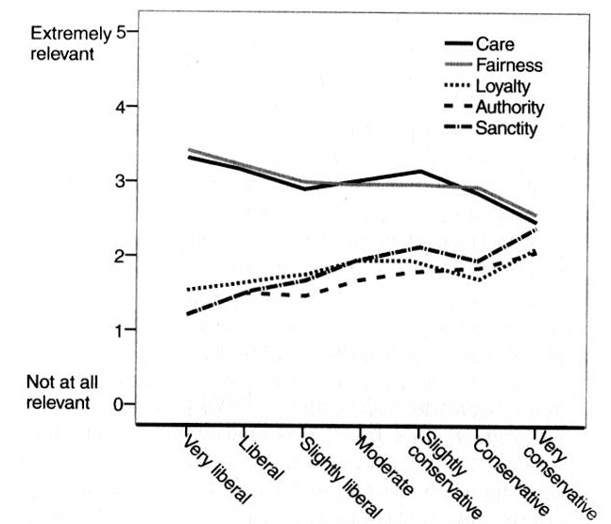
Matthew 7:1-6 (NRSV)

Judging Others
7 “Do not judge, so that you may not be judged. 2 For with the judgment you make you will be judged, and the measure you give will be the measure you get. 3 Why do you see the speck in your neighbor’s eye, but do not notice the log in your own eye? 4 Or how can you say to your neighbor, ‘Let me take the speck out of your eye,’ while the log is in your own eye? 5 You hypocrite, first take the log out of your own eye, and then you will see clearly to take the speck out of your neighbor’s eye.
Profaning the Holy
6 “Do not give what is holy to dogs; and do not throw your pearls before swine, or they will trample them under foot and turn and maul you.

Matthew 7:1-6 (MSG)

A Simple Guide for Behavior
7 1-5 “Don’t pick on people, jump on their failures, criticize their faults— unless, of course, you want the same treatment. That critical spirit has a way of boomeranging. It’s easy to see a smudge on your neighbor’s face and be oblivious to the ugly sneer on your own. Do you have the nerve to say, ‘Let me wash your face for you,’ when your own face is distorted by contempt? It’s this whole traveling road-show mentality all over again, playing a holier-than-thou part instead of just living your part. Wipe that ugly sneer off your own face, and you might be fit to offer a washcloth to your neighbor.
6 “Don’t be flip with the sacred. Banter and silliness give no honor to God. Don’t reduce holy mysteries to slogans. In trying to be relevant, you’re only being cute and inviting sacrilege.

MATTHEW 18:15-20
Reproving Another
15 ‘If another member of the church sins against you, go and point out the fault when the two of you are alone. If the member listens to you, you have regained that one. 16But if you are not listened to, take one or two others along with you, so that every word may be confirmed by the evidence of two or three witnesses. 17If the member refuses to listen to them, tell it to the church; and if the offender refuses to listen even to the church, let such a one be to you as a Gentile and a tax-collector. 18Truly I tell you, whatever you bind on earth will be bound in heaven, and whatever you loose on earth will be loosed in heaven. 19Again, truly I tell you, if two of you agree on earth about anything you ask, it will be done for you by my Father in heaven. 20For where two or three are gathered in my name, I am there among them.’
Forgiveness
21 Then Peter came and said to him, “Lord, if another member of the church[g] sins against me, how often should I forgive? As many as seven times?” 22 Jesus said to him, “Not seven times, but, I tell you, seventy-seven[h] times.

EPHESIANS 4: 1-5

Unity in the Body of Christ
1I therefore, the prisoner in the Lord, beg you to lead a life worthy of the calling to which you have been called, 2 with all humility and gentleness, with patience, bearing with one another in love, 3 making every effort to maintain the unity of the Spirit in the bond of peace. 4 There is one body and one Spirit, just as you were called to the one hope of your calling, 5 one Lord, one faith, one baptism, 6 one God and Father of all, who is above all and through all and in all.

GALATIANS 5: 16-26

The Works of the Flesh
16 Live by the Spirit, I say, and do not gratify the desires of the flesh. 17 For what the flesh desires is opposed to the Spirit, and what the Spirit desires is opposed to the flesh; for these are opposed to each other, to prevent you from doing what you want. 18 But if you are led by the Spirit, you are not subject to the law. 19 Now the works of the flesh are obvious: fornication, impurity, licentiousness, 20 idolatry, sorcery, enmities, strife, jealousy, anger, quarrels, dissensions, factions, 21 envy,[e] drunkenness, carousing, and things like these. I am warning you, as I warned you before: those who do such things will not inherit the kingdom of God.
The Fruit of the Spirit
22 By contrast, the fruit of the Spirit is love, joy, peace, patience, kindness, generosity, faithfulness, 23 gentleness, and self-control. There is no law against such things. 24 And those who belong to Christ Jesus have crucified the flesh with its passions and desires. 25 If we live by the Spirit, let us also be guided by the Spirit. 26 Let us not become conceited, competing against one another, envying one another.

Resources for further study:

- “Moral Arguments” from “You Are Not So Smart” Podcast:
  - https://soundcloud.com/youarenotsosmart/088-moral-arguments

- Marshal Rosenberg: Non Violent Communication:
  - Basics: https://www.youtube.com/watch?v=M-129JLTjkQ
  - 9 hour training: https://www.youtube.com/watch?v=UEqmZ2E1o64

- “Crucial Conversations: Tools for Talking when the Stakes are High” Kerry Patterson et al book by McGraw Hill publishing
  - Video intro: https://www.youtube.com/watch?v=EFaXx3pgaxM

