CHANGING LANDSCAPE OF MINISTRY INSIGHTS:

We know the world is changing in so many ways. We know that the institutional church is not the center of culture or people’s lives as it once was. We know that each new generation is less likely to affiliate with an institutional religion though they may be deeply spiritual. (And we know that this is the first time in the history of this planet when 6 distinct generations could enter the same building at the same time). This document is an overview compilation of research and insights from a variety of sources with a few caveats:
- This is by no means comprehensive. (That would take a book…or several)
- This is by no means conclusive. (New research keeps bringing new insights and nuances)
- This is NOT a template or list of things to do. It is NOT about what we can do to get more people (young people/families) into our pews with pledges for our plates.

HERE IS ONE BASIC INSIGHT. [Pew Research and Gallup are a good source for these statistics]
- 80 - 95% of people claim a belief in something ‘other’, what some might call God. (Depending on how researchers ask the question.)
- 80 – 95% of people claim to pray to a divine something (Depending, again, on how the question is asked).
- However, people’s attendance at a Christian church on any given weekend, based on church attendance reports, averages less than 20%. (with older generations being at least twice as likely to attend as younger generations.)
- Roughly, this means that nearly 2/3rds of the population believe in God but do not typically attend church. And that number is increasing with each new generation.

SHIFTS IN THE LANDSCAPE:
- Church is no longer central to the culture. Sunday’s are not sacred cultural time. Being a good citizen does no presuppose being a good church member.
- There a plenty of things for people to do and plenty of places where they can find spiritual nurture outside of church.
- Globalization: we are more instantaneously aware of things happening around the world. And more aware of how they all interrelate and interact to shape our daily lives.
- Information access: global communication and information access is possible from a cell phone.
- Connectivity: people have many more ways to connect with many more people, though not necessarily with greater depth. Paired with an increased reliance on and belief in technology
- Pluralism: We are living in an era with an increasing sense of diversity in ideology, religion/creed, ethnicity, orientation, etc
- Mobility: People are more likely to relocate frequently in the course of their lifetime. Less rootedness in a single location
- Careers: Education and hard work are no longer necessarily a formula for career advancement, nor a promise for job security. Paired with the perception of a shrinking middle class and increasing economic disparity
- Polarization: There is an increasing divide with less listening and compromise between different ideologies. Paired with a decline in civil discourse and sharper rhetoric.
- Shrinking Majority: There is a less and less clear majority of beliefs, ethnicities, etc
- Informality: lessening of strict dress codes, and norms and hierarchies

LEARNINGS FROM THE “NONES” AND “DONES”*

WHAT ARE FOLKS SAYING THEY ARE MOVING AWAY FROM
- Churches are hypocritical; behaving in meetings and in private contrary to their teachings
- Churches impose doctrine and morals, you have to believe, behave and dress like to members to be accepted.
- Churches are meddling in politics (They are passionate about social justice issues, but they don’t want religion using political power to impose moral rules or laws)
- Churches language and behavior are vitriolic/toxic on moral issues (as portrayed in media)
- Churches are out of touch
- Churches are boring and irrelevant.

WHAT FOLKS ARE DRAWN TOWARDS (In their Spiritual, but not Religious quest):
- Conversation and dialogue: Informality
- Clarity of passion and identity (a spiritual group that knows what it most values and acts on it)
- Acceptance and belonging;
  - a community in which all are authentically included regardless of creed, orientation, socio economics, abilities, race, etc.
  - a community that welcomes them as they are and is open to being changed by the ideas, experiences and questions they bring.
- Meaningful generativity (actively making a difference in the community and world)
  - Peace – Poverty – Planet – People (The UCC “Be The Church” banner captures comments and longings from this group)
- Mystical encounter with Holy
- Connection to sacred natural world
- Tradition – not Traditionalism: a church that has meaningful and moving ritual.
- Much of this is captured or summarized in the ‘requirements’ of Micah 6:8
  - Do Justice – Love Kindness – Walk Humbly

WHAT IS THEIR STYLE/APPROACH/WAY OF OPERATING:
- Expert is in the room. They are not interested in being lectured at.
- Experience is authority. Disillusioned with institutional failure (military, entertainment, educational, political, religion, legal, corporate/industrial)
- Non hierarchical
- Individual development first, communal second.
- God is within us and our environment (nature). Not out there in some heaven or throne.
- No mediator of God’s presence or teachings is needed, crowdsourcing God experience.
- Multiple paths to God; no one faith has a corner on the market
- Meaningful Ritual
- Actively involved in making a difference, particularly hands on approach to care for peace, poverty, planet and people.

*NONES = those people who mark “none of the above” when listing religious affiliation
DONES = those people who were once part of a church but have left; they’re ‘done’ with it.

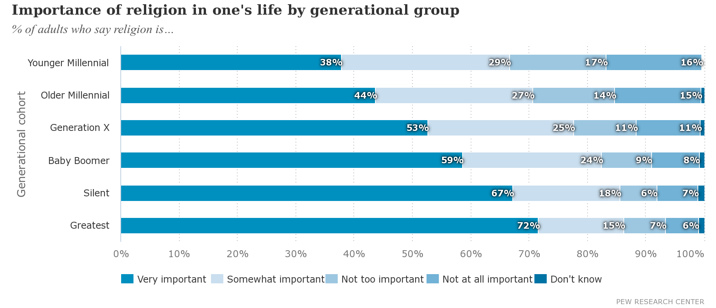
From Pew Research

